# **CS 1101-01: Programming Assignment Unit 1**

Godknows Egi

Bachelor of Science in Computer Science, Uopeople

CS 1101-01 - AY2024-T3: Introduction and Fundamental Concepts

Bianca Gilyot

February 7th , 2024

**Learn from you mistakes! :Part 1**

In Chapter 1, section 1.9 Exercises (pg. 7) of your textbook, Exercise 1.1 suggests making mistakes when experimenting with a new programming feature. This kind of experiment helps you remember what you read, and also get information on the error messages.

Answer the following questions (a) to (d).by explaining some frequently occurring errors. To help you answer the questions, write the code in Python and run it to produce output for each of the questions.

1. If you are trying to print your name, what happens if you leave out one of the quotation marks or both, and why?
2. What is the difference between * and ** operators in Python? Explain with the help of an example.
3. In Python, is it possible to display an integer like 09? Justify your answer.
4. Run the commands type('67') and type(67). What is the difference in the output and why?

**Solution for question A:P1**

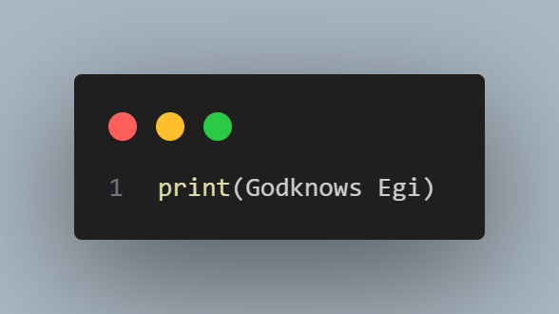

*Code for Question A,P1*

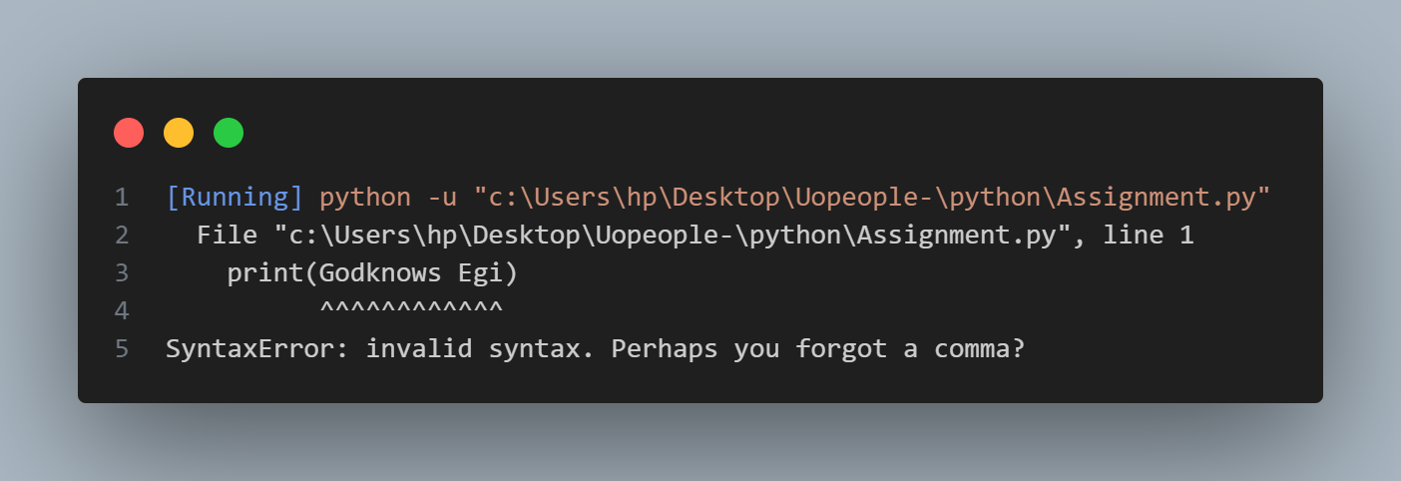

*Output for Question A,P1*

The Output for the code resulted into an error **SyntaxError: invalid syntax**, Which is as a result of no comma closing the text value to make it a valid string type.

**Solution for question B:P1**

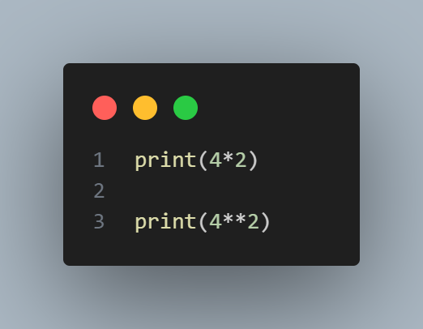

*Code for Question B,P1*

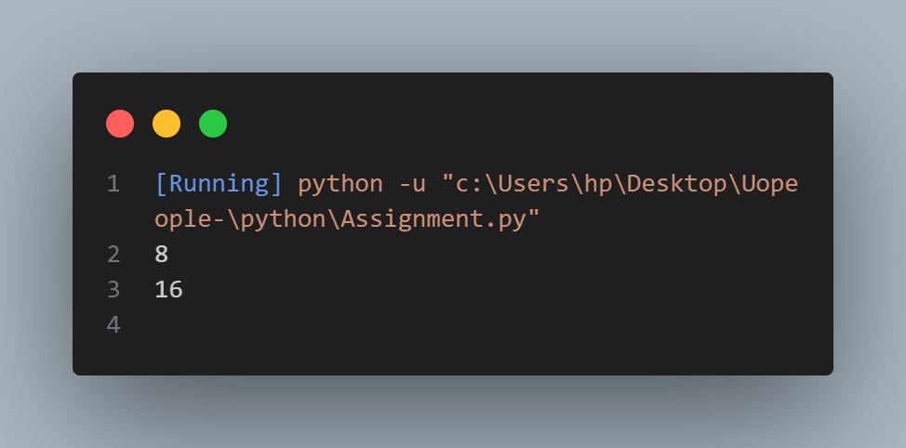

*Output for Question B,P1*

The Output is for 4 * 2 = 8, A single asterisk symbol means a **multiplication operator** in python as shown in Downey, A. (2015,). Think Python: How to think like a computer scientist ,*Chapter 1 - The Way of the Program (pp. 1.4)*, Which means 4 * 2= 8 in a print function.

The second function has a double asterisk ** which means an exponential operator as explained in Downey, A. (2015,). Think Python: How to think like a computer scientist ,*Chapter 1 - The Way of the Program (pp. 1.4)*, Which means it raises a number to a power i:e 4**2 = 16.

**Solution for question C:P1**

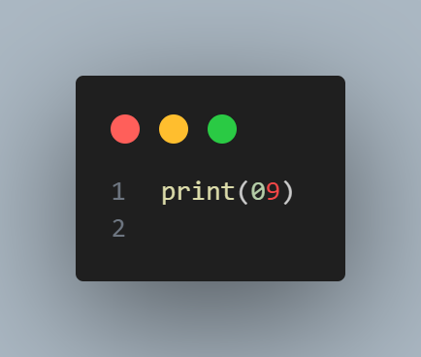

*Code for Question C,P1*

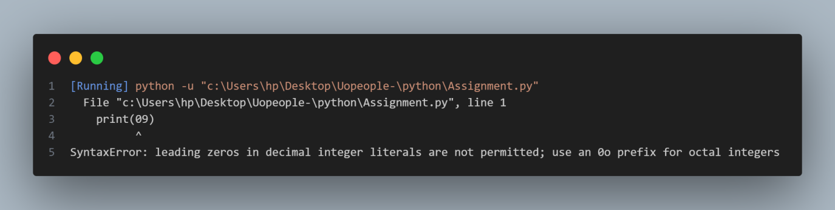

*Output for Question C,P1*

In Python, it's not directly possible to display an integer like 09 because leading zeros in decimal integer literals are not permitted, Which will result to a syntax error as shown on the code output. To achieve this will require an extra step by formatting the inputs.

**Solution for question D:P1**

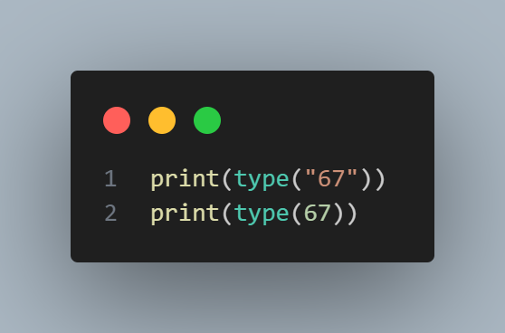

*Code for Question D,P1*

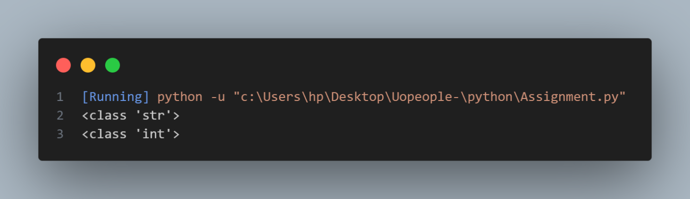

*Output for Question D,P1*

The first Output is of class/category string **<class 'str'>** while the second output is of class number or integer **<class 'int'>.** The difference is the category/class of this value type , Strings are wrapped around with a comma while numbers aren't.

**Part 2**

Write a Python program for each of the following questions (a) to (d).

1. To multiply your age by 2 and display it. For example, if your age is 16, so 16 * 2 = 32 b
2. Display the name of the city, country, and continent you are living in.
3. To display the examination schedule (i.e., the starting and the ending day) of this term.
4. Display the temperature of your country on the day the assignment is attempted by you

**Solution for question A:P2**

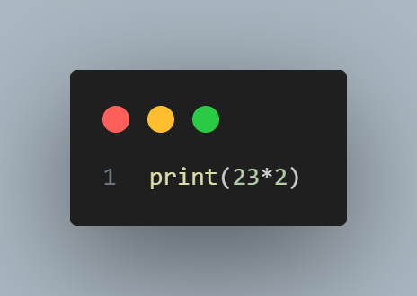

*Code for Question A,P2*

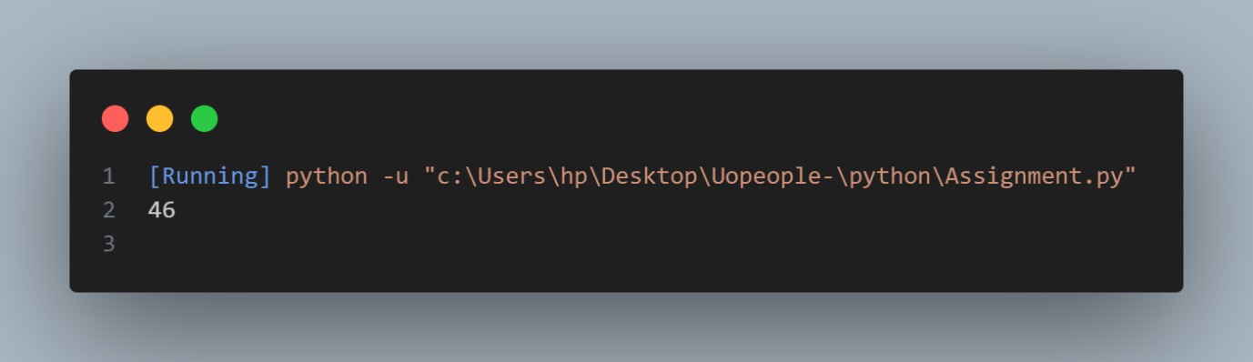

*Output for Question A,P2*

The code output = 42, After multiplying my age by 2 in a print function.

**Solution for question B:P2**

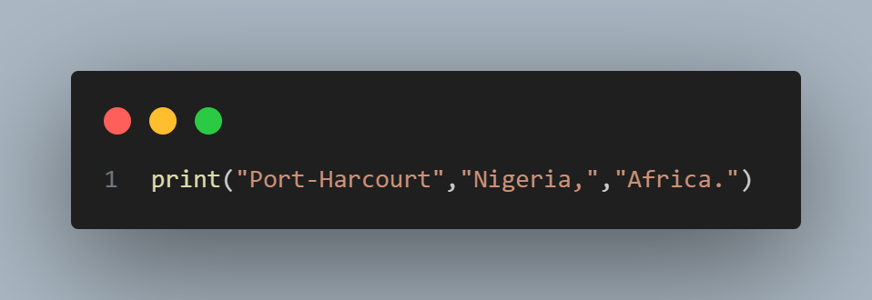

*Code for Question B,P2*

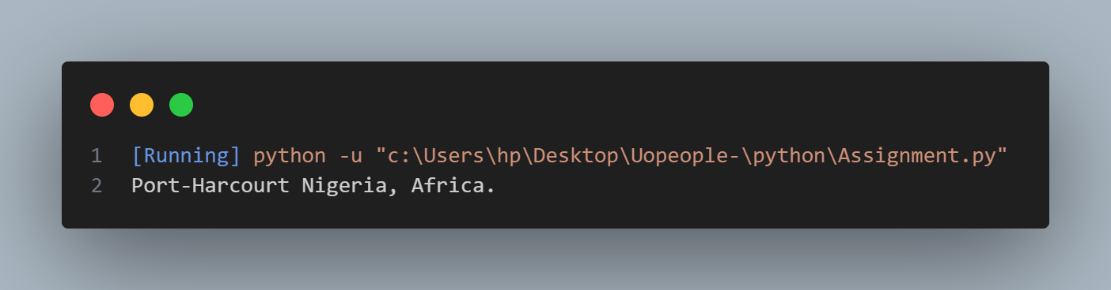

*Output for Question B,P2*

I was able to display my City, Country and Continent in a print function, I used a string concatenation separated by a comma in a print function as explained in an article by Geeks for Greeks ***How print() works in Python,*** On how to output multi-line strings.

**Solution for question C:P2**

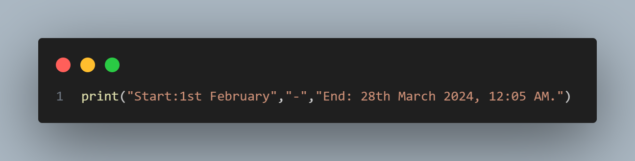

*Code for Question C,P2*

*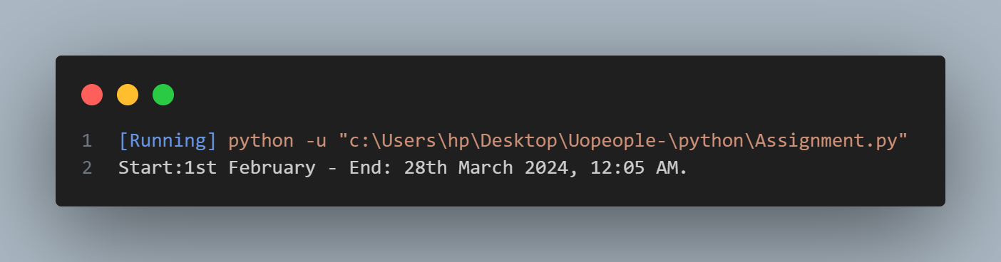*

*Output for Question C,P2*

I was able to display the start-end date of the term in a print function, I used a string concatenation separated by a comma in the print function.

**Solution for question D:P2**

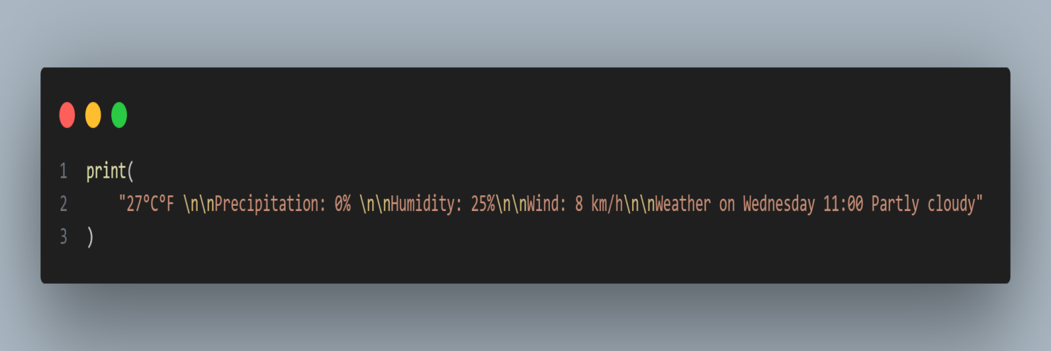

*Code for Question D,P2*

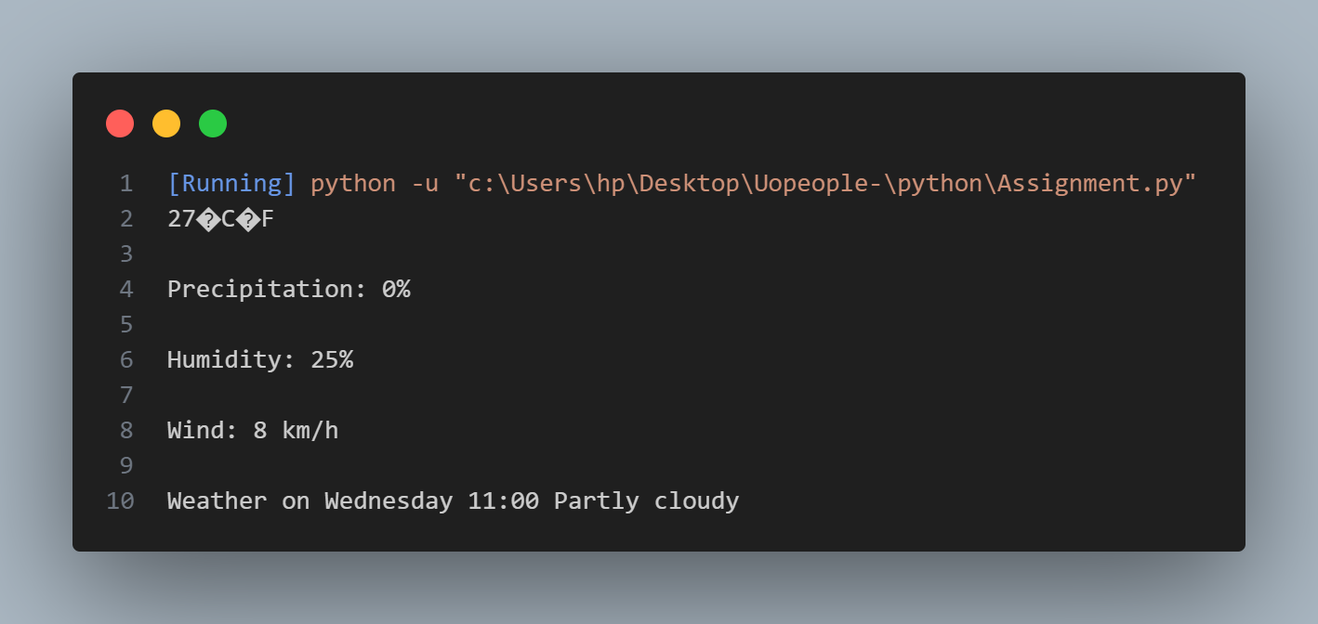

*Output for Question D,P2*

I was able to display the temperature of my country in a print function, I used a string concatenation separated by a comma and a sting literal \n which adds a new blank line while printing a statement as shown in an article by Geeks for Greeks ***How print() works in Python.***

**References**

Downey, A. (2015,). Think Python: How to think like a computer scientist ,*Chapter 1 - The Way of the Program (pp. 1.4)*

<https://greenteapress.com/thinkpython2/thinkpython2.pdf>

Geeks for Greeks ***How print() works in Python***

*<https://www.geeksforgeeks.org/python-output-using-print-function/?ref=ml_lbp>*